Environmental Literacy Carbon Assessment:
--- Elementary School Level, Form A ---
Science is easier to understand if you can make connections between what you know now and the new ideas that you are studying. This is a test that will help us to understand what you know now. Please answer these questions as carefully and completely as you can. If you are not sure of the answer, please write about any thoughts that you have. If you can help us to understand how you think about these questions, then we can do a better job of explaining science in ways that make sense to you.

Please put your initials (not your full name) in the boxes
Date ________________ | First | Middle | Last
Class ____________________________ Teacher _______________________

1. How do you think the foods you eat can help you move your little finger?

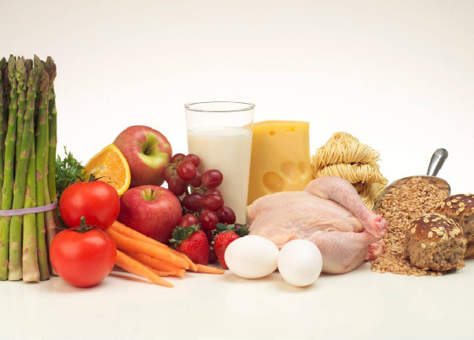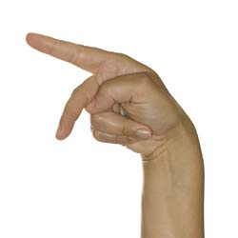

Please explain how the foods you eat help you move your little finger. Tell as much as you can about how food that you eat with your mouth can help your finger to move.

2. When the baby was five months old, she weighed 22 lb. After 7 years, the tiny baby has grown into a big girl, weighing 50 lb. What did the baby need in order to gain more and more weight? Please circle Yes or No for each of the following and explain your choices.

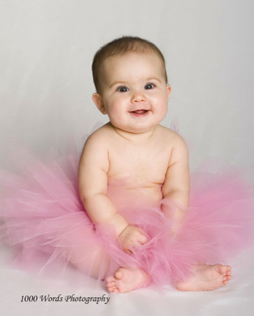 | 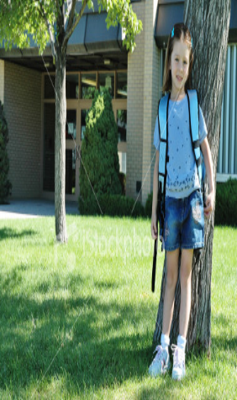
The baby weighed 22 lb when she was 5 months old. | The baby has grown into a big girl, weighing 50 lb.

Things | Does it help the baby to grow? | If it helps the baby to grow, how does the baby’s body use it?
Sunlight | Yes No
Water | Yes No
Air | Yes No
Food | Yes No
Exercise | Yes No

3. A small oak tree was planted in a meadow. After 20 years it has grown into a big tree, weighing 250 kg more than when it was planted. What did the tree need in order to gain more and more weight? Please circle Yes or No for each of the following things and explain your choices.

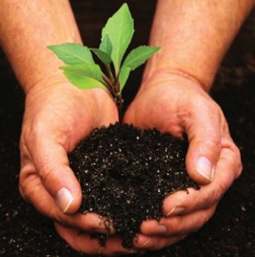 | 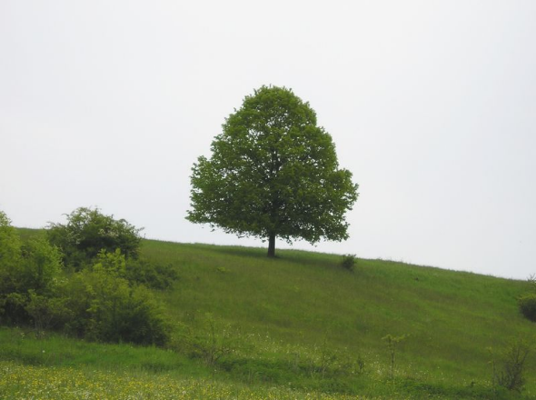
A small oak tree | A big oak tree weighing 250 kg more than it was planted

Things | Does the tree need it to grow? | If the tree needs it, how does the tree use it?
Sunlight | Yes No
Soil | Yes No
Water | Yes No
Air | Yes No

4. When a person loses weight, what happens to some of the fat in the person’s body? Choose ONE answer that you think is best.
(a) The fat leaves the person’s body as water and gas.
(b) The fat is converted into energy.
(c) The fat is used up providing energy for the person’s body functions.
(d) The fat leaves the person’s body as feces.
Explain your answer to the previous question. Why do you think this happens to the fat?

5. The pictures below show three things happening.

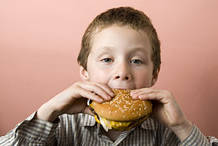 | 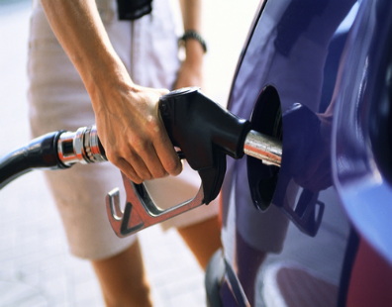 | 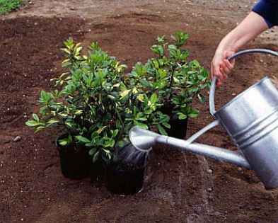
A. Eating a hamburger | B. Filling up a car with gasoline | C. Watering plants

a. Are they alike or different? Please explain your answer.

b. A scientist says that A and B are similar events, but picture C is different from A and B. Do you know why? Please explain why C is different from A and B.

6. Why do people use gasoline instead of water to run their cars?


7. An apple is eaten by a child and digested in his body. a. What happens to the apple when it is digested?

b. Do you think the apple the child ate with his mouth can help his feet to grow? If your answer is yes, please explain how the apple can help the child’s feet to grow. If your answer is no, please explain why the apple cannot help the child’s feet to grow.

8. Do you think plants need light to live? Why? Please choose the ONE answer that you think is best.
- Not all plants need light to live.
- Light warms the plants.
- Without light, plants will die in darkness.
- Light helps plants to be healthy.
- Light helps plants to make foods.
- Light helps plants breath.

Please explain why you think that the answer you chose is better than the others. (If you think some of the other answers are also partially right, please explain that, too.)
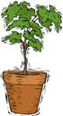

9. A tree falls in the forest. After many years, the tree will appear as a long, soft lump barely distinguishable from the surrounding forest floor.
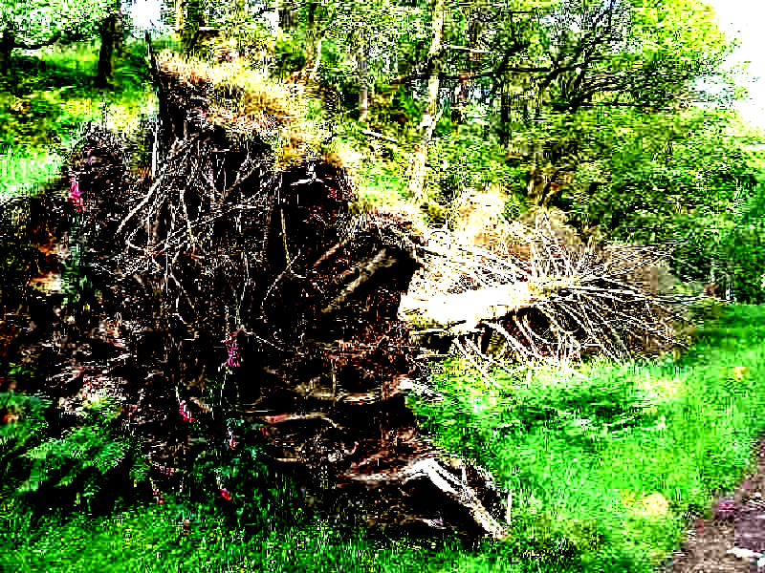

a. The lump on the forest floor weighs less than the original tree. Where would you find the matter that used to be in the tree? What happened to it?

b. What caused those changes in the wood? Explain as well as you can how these changes happened.

c. Is energy involved when the tree decays?

Circle one: Yes / No

If your answer is yes, please explain how energy is involved.

10. Do you think that wood is a mixture of different things?

Circle one: Yes / No

Please explain your ideas about what materials make up wood.

11. Explain how are the following living things connected with each other:
- Grass.
- Cows.
- Human beings.
- Decomposing bacteria.

